Number | Date | Changed By | Section | Description
1 | 14 Jul 2011 | Martin Honer | All | Original Release
- Machine Type

- Vertical Spindle Ingot Scalping Machine controlled by a Siemens S7-317F-2DB PLC linked to SINAMICS servo drives.

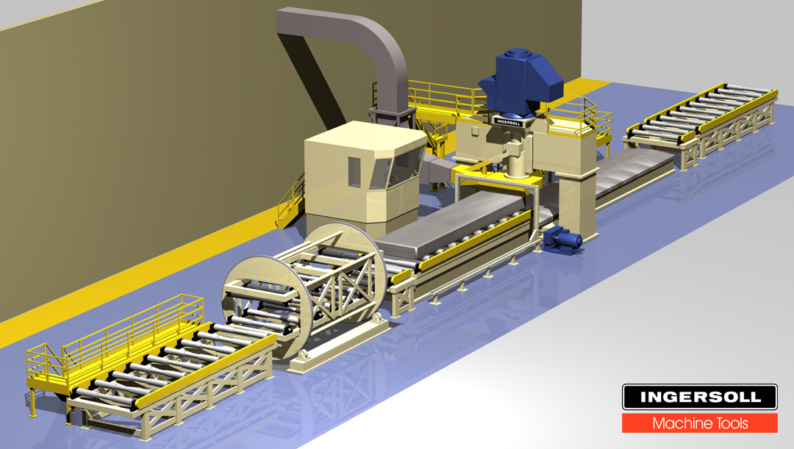
In Feed
Barrel Turnover
Out Feed
Operator Pulpit
Machine Table
Scalper Cutter
Ingot
To Fan and Crusher Room
Laser Gantry
INGERSOLL SCALPER

- Reference Machines
- Machine mechanically similar to 40123 Elval Scalper
- Reference logic to be used is 2N03030 Bohai Scalper

- Operator Console
- (1) Operator console located in pulpit on side of machine.
[Similar to 2N03030 Bohai, but a few more controls. See schematics.]
- Fan and crusher minimal control panels located in remote room
[Identical to 2N03030 Bohai]

- Motors

MOTOR FUNCTION | MANUFACTURER | POWER  (kW/HP) | V/Ph/Hz | SPEED  (RPM) | FLA  (Amps)
Spindle Positioning | Siemens  1FT6105-8AC71-1AB0 | 8/10.72 | Variable | 2000  Rated | 17.6
(7) Conveyor Rollers | Siemens  1LA6131-2AA61 | 8.6/11.53 | Variable | 3600  (Run 2500) | 14.8  (x 7)
Spindle motor | ABB  AMI 560L12A VAH | 933/1250 | 4000/3/60 | 600 | 167
Crusher motor | ABB  HXR 500LK8 | 597/800 | 4000/3/60 | 900 | 106
Fan motor | ABB  HXR 400LJ6 | 373/500 | 4000/3/60 | 1200 | 65
(2) Hydraulic (main, turnover) | WEG  # | 75/100 | 480/3/60 | 1800 | 115  (x 2)
(2) Hydraulic (main, machine) |  | 7.5/10 | 480/3/60 | 1800 | 12.4  (x 2)
Hydraulic (circulating) | WEG  #00318EP3E100L | 3.7/5 | 480/3/60 | 1800 | 5.9
Spindle Lubrication (pressure) | WEG  #00218EP3E100L | 3.7/5 | 480/3/60 | 1800 | 5.9
Spindle Lubrication (circulation) | WEG  #00418EP3E112M | 3.7/5 | 480/3/60 | 1800 | 5.9
Spindle Lubrication (return) | DELTA  CW43-3304 Mtr/Pump  3HP 182TC | 2.2/3 | 480/3/60 | 1800 | 3.86
(2) Way Lube (table) | WEG  # | 0.180/0.25 | 480/3/60 |  | 0.7
Way Lube (vertical return) | DELTA  C8+C374 Mtr/Pump 0.75HP | 0.55/0.75 | 480/3/60 | 1800 | 1.4
Way Lube (table return) | DELTA  CW45-3754 Mtr/Pump  5HP 213TC | 3.7/5 | 480/3/60 | 1800 | 5.9
Way Lube (supercharge) | WEG  #00218EP3E100L | 3.7/5 | 480/3/60 | 1800 | 5.9
(2) Laser Gantry drive | Siemens  1FT6044-1AF71 | 1.4/1.88 | Variable | 3000 | 2.9  (x 2)

- Table
- Table speed and positioning is controlled by an absolute encoder on the motor. [Similar to 2N03030 Bohai, but new Sinamics drives]
- Table speed is dynamically adjusted during cutting [Identical to 2N03030 Bohai]
- (2) table end stops are raised and lowered hydraulically [new]

- Conveyors
- There are seven different conveyor systems on this machine:
- In feed rollers
- Turnover top rollers
- Turnover bottom rollers
- Intermediate transfer conveyor rollers
- Table rollers #1
- Table rollers #2
- Out feed rollers including Intermediate transfer conveyor rollers
[Similar to 2N03030 Bohai, except for the additional second set of table rollers that Bohai did not have.]
- Each set of rollers has sensors that identify when the leading edge of the ingot has reached the end of the rollers. [Same as 2N03030 Bohai]
- The infeed conveyor has an easy-up motion to raise the ingot to the height of the turn-over rollers. [New]

- Ingot Clamping
- Ingot clamping in the turnover is performed with (4) sets of side clamps and (5) sets of top clamps to securely hold the ingot captive while rotating it to the second side for scalping. [2N03030 Bohai had only 3 sets of side and top clamps]
- Clamping of the ingot on the table uses 4 sets of clamps. [2N03030 Bohai had only 3 sets of clamps]

- Spindle Vertical Positioning
- Servo motor controlled with motor encoder for velocity and separate encoder for position. Brake on motor and dampener on spindle housing – motor must be OFF when the dampener is applied for cutting cycle. (Similar to 2N03030 Bohai)

- Spindle Motor Control
- Dynamic braking is used for the spindle motor [Similar to but not identical to 2N03030 Bohai]
- Motor ON/OFF control (Similar to 2N03030 but with Profibus interface)

- Laser System
- HMI interfaces to a LMI MicroMaster 400 and (3) Gocator lasers mounted on a gantry to measure ingot surface. PLC logic starts and stops laser gantry system. [New]
- Gantry driven by two motors with electronic synchronization. [New]

- Cameras
- (6) cameras mounted around machine and (2) monitors in pulpit. [No logic required.]

- Chip Collection System
- The chips generated by the scalper are conveyed to a crusher through the ductwork. [Same as 2N03030 Bohai]
- A heavy-duty chip transport fan with open impeller generates the air volume that is required to transport the pulverized chips. [Same as 2N03030 Bohai]
- Chip diverter in the ductwork can be positioned to send chips to 3 different locations based on operator input and type of alloy. [New]

- Hydraulics
- Hydraulic Power Unit:
Power unit includes: (5) pumps (2 automation hydraulic pumps, 2 machine hydraulic pumps, hydraulic recirculation pump, low level, high level, over temp, dirty filter, press ok, re-circulation press ok, re-circulation dirty filter etc..
[Similar to 2N03030 Bohai]
- Several ball valves with switches for which the combinations have to be checked before starting pumps. [New]
- (2) table end stops are raised and lowered hydraulically [2N03030 Bohai had one stop]
- Hydraulically controlled table and turnover clamps [similar to 2N03030 Bohai]
- Turnover rotation hydraulically controlled [identical to 2N03030 Bohai]

- Machine Lubrication
- Table way lube uses two pressure pumps, a supercharge pump and a return pump.
- Vertical spindle head lube uses Trabon valves with Cycle switches and a return pump.

- Spindle Bearing Lubrication
- A separate oil tank incorporated into the hydraulic power platform provides lubrication for the spindle bearings. This system uses a pressure pump, a circulation pump and a return pump. [Similar to 2N03030 Bohai, but more monitoring of oil level, temperature, etc.]

- Cutter Lubrication
- Mist lubrication is delivered to the spindle cutter during a scalping cycle. [Identical to 2N03030 Bohai]

- Pneumatics
- Air is used to purge the vertical spindle air ring [Identical to 2N03030 Bohai]
- A chip deflector is located inside of the spindle cutter shroud and aids the shroud in directing the chips into the chip collection system. The chip deflector is automatically raised and lowered (based on the pending table direction) using a pneumatic cylinder. [Identical to 2N03030 Bohai]
- Air is mixed with oil for mist cutter lubrication. [Identical to 2N03030 Bohai]
- Table brake is pneumatically-released [New]
- Ingot Overstock and Ingot Present sensors box pressurization. [no logic]

- Chiller
- A chiller is provided to remove heat from the vertical spindle lubrication fluid and hydraulic fluid. [Same as 2N03030 Bohai]

- Communications & Interfaces
- Digital I/O to Infeed Crane system [New]
- Digital I/O to Outfeed Crane system [New]
- Digital I/O to Can Reclamation Center for Chip collection [New]
- Ingersoll HMI interfaces to Factory MES system through TCP/IP messaging over Ethernet. [New]
- Ingersoll HMI interfaces to a customer-supplied barcode system. [New]

- Gating
- 8 perimeter gates: (2) operator entry; (6) maintenance use. All gates use DOLD gate interlocks. [New]

- Control Cabinets
- The medium voltage (4160V 3-phase, 60Hz) switchgear devices consist of the starters and motor protection relays for the spindle motor, the crusher motor, and the fan motor. The medium voltage cabinets are located in a separate control room.
- Medium voltage = 4160 VAC, 3-phase, 60 Hz, 3000 KVA
- The Motor Control Center (MCC) is another set of cabinets that contain the motor starters and motor protection relays for the 480V equipment. This includes all the hydraulic pump motors, lube pump motors, conveyor roller motors, table drive motor and spindle positioning drive motor. The MCC cabinets are located in the electrical control room.
- Low voltage for MCC = 480 VAC, 3-phase, 60 Hz, 600 Amp, 300 KVA
- PLC Control cabinets are located in the electrical control room with the MCC cabinets.
- Space heaters in the MV and MCC cabinets controlled by thermostats in the cabinets. [New, no logic]
- Two independent 230V single-phase feeds, one “DIRTY” and one “CLEAN”, are used to supply equipment that stays “hot” even when the machine is shutdown which includes the PLC.

- Miscellaneous Items
- A Bently-Nevada vibration monitoring system is installed on the spindle, crusher, and fan. The customer’s MES system can monitor this data via Ethernet. The PLC monitors vibration alarm faults using hard wired I/O. [New]
- RTD’s measure temperatures of the following equipment: Spindle, Crusher and Fan motor winding temperatures; Spindle, Crusher and Fan motor bearing temperatures; Spindle, Crusher and Fan bearing temperatures. This data is passed over Profibus to the PLC. [Similar but more extensive than 2N03030 Bohai]
- Profibus is used extensively to interconnect the different devices on the machine including motor starters and drives. [Similar but more extensive than 2N03030 Bohai]

